Cites references throughout using appropriate APA format. Provides references at end. Consistently uses grammatically-correct posts with little or no misspellings. Provide references at end. Please respond in depth and very detailed. At least 2 paragraphs or however long it takes to respond to questions. If possible use the book Edelman, C. L.& Mandle, C.L. (2018). Health Promotion throughout the Lifespan, 9th ed, Mosby/Elsevier, ISBN#: 978-0-323-56910-1.

- Choose a health-related issue for individuals that is addressed on the Healthy People 2020 list; i.e. physical activity for adolescents, cigarette use by adults. Discuss health promotion activities associated with the issue that you identified with an aim at illness prevention.

Healthy People 2020 link is in the course and here as well. http://healthypeople.gov/2020/default.aspx

- Look at the Healthy People 2020 Selected Examples of
National Health-Promotion and Disease-Prevention Objectives for families in
Edelman & Mandle (your textbook) on page 155; Box 7-3.

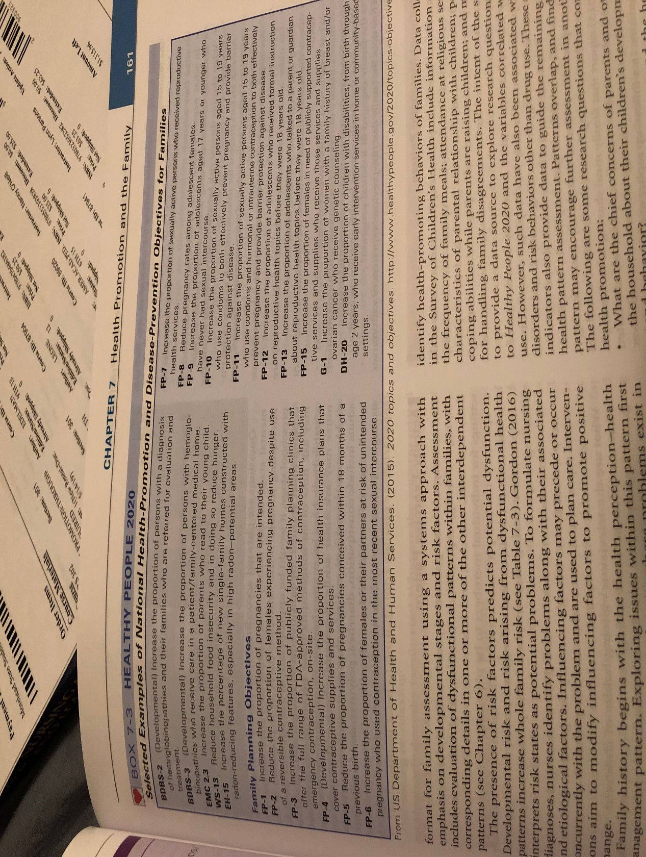
(BOX 7-3 ABOVE)

Choose a health related issue for families that is addressed on the Healthy
People 2020 list; i.e. reduce proportion of person’s binge drinking of
alcoholic beverages, reduce portion of adult obesity. Discuss health promotion
activities associated with the issue that you identified with an aim at illness
prevention.

Healthy People 2020 link is in the course and here as well.
www.healthypeople.gov/2020/topicsobjectives2020/default.aspx

- A community has identified teenage drinking and driving has
caused 7 teenage deaths in a 3 month period. Alcohol and drug education is
taught during the 1st year at the local high school, but drivers
education classes are not offered because the school cannot afford the program.
Parents who live in this community are concerned. [See Edelman & Mandle
(your textbook) on page 177 - Box titled, Think About It. Teenagers: Drinking and Driving.]
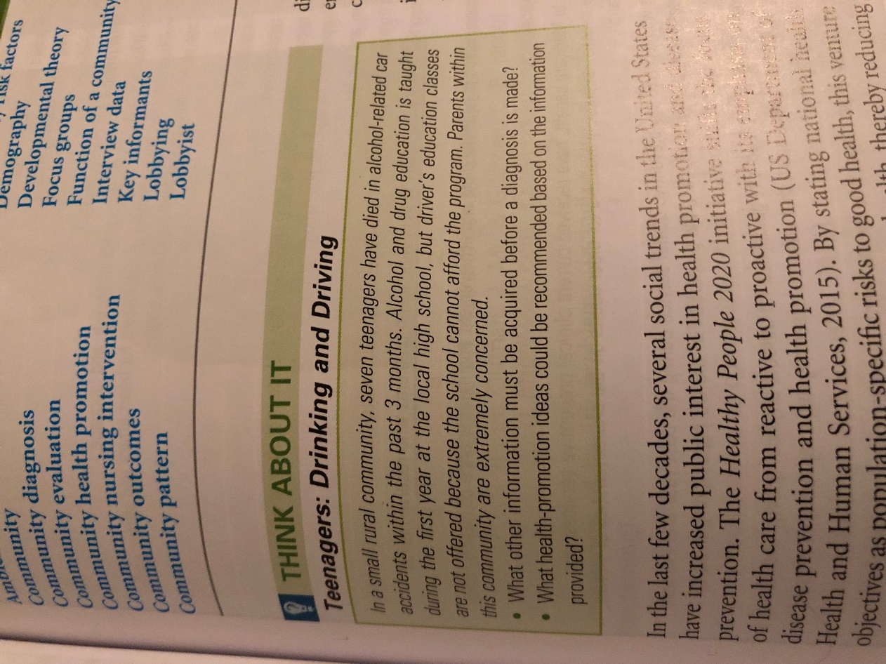
- What health promotion programs would you recommend based on
the information provided?
- What individuals in the community would you want to involve?
- Can you think of non-health related community members that would be good
additions to a group assembled to help with interventions in this situation?

- You are asked to provide health teaching to a group of preschool children. Select a teaching topic and share –
a] teaching principles,
b] domains of learning used and why,and
c] suggested teaching activities.
Examples for teaching topics include “brushing teeth” “look both ways before crossing the street
[safety]” [See Edelman & Mandle (textbook) on page 234 -Table 10-2 - Domains of Learning, Teaching Strategies, and Examples of Desired Outcomes Related to a Behavior Change.]
Table 10-2
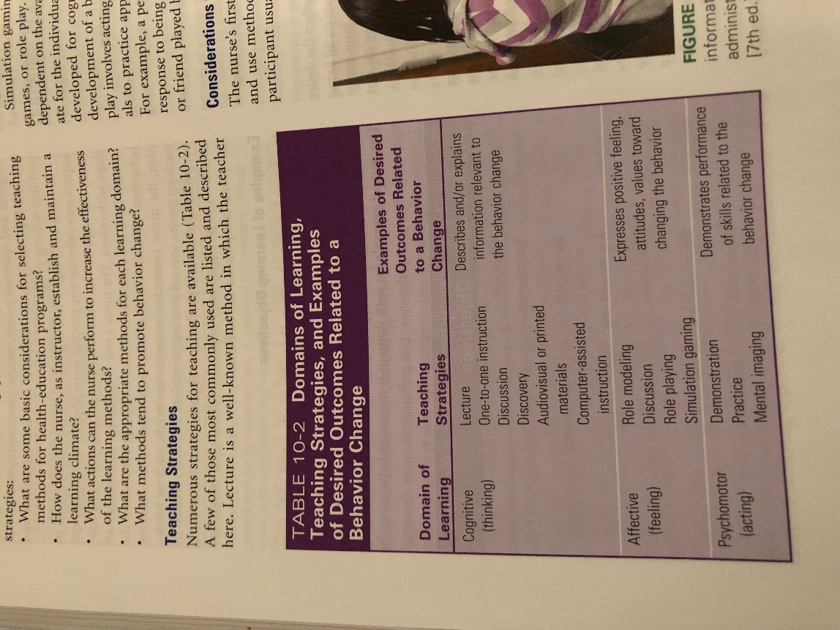

Scenario:
- A mother of three (3) children ages 4, 7 and 11 works part-time and goes to school to study for a Master’s degree full time. Her husband works away from the home during the week and is home on weekends. She reports that she is stressed to the point that it affects her sleep at night. After reviewing chapter 13 in See Edelman & Mandle (textbook) what stress management interventions would you recommend? Please elaborate.

(Stress management interventions that are in chapter 13 are
Developing self-awareness, nutrition: healthy diet, physical activity, sleep hygiene, cognitive-behavioral restructuring, affirmations, assertive communication, social support, empathy, healthy pleasures, spiritual practice, clarifying values and beliefs, setting realistic goals, humor, and engaging in pleasurable activities)

Holistic Interventions
- A person has seen a physician for migraine headaches and no origin for the pain can be found after multiple tests are done. Review the many holistic interventions shared in chapter 14 [See Edelman & Mandle (textbook).] Which one of these interventions may be beneficial for the person with migraine headaches? Share why you chose this intervention.

